Requested items:

1. A well developed and documented Navigation Map Integration Plan

Examples of content and elements to include are:

* 1. Physical system architecture plan (with it include laptop, compute platform, separate navigation computer, communication network and protocol between the controllers if needed)
  2. Software Architecture diagrams/design – Data Flow Diagrams, Software Flow Charts, showing routing and re-routing functionality and integration with vehicle controls.
  3. Description of strategy for navigation routing and re-routing, concurrent routing options running, or single stream routing that gets blocked and a rerouting gets triggered for re-calculation?

1. A list of questions for the 1:1 session with David Craig for Mapping

**1. Navigation Map Integration Plan:**

Fig 1. The Mapping Software Architecture

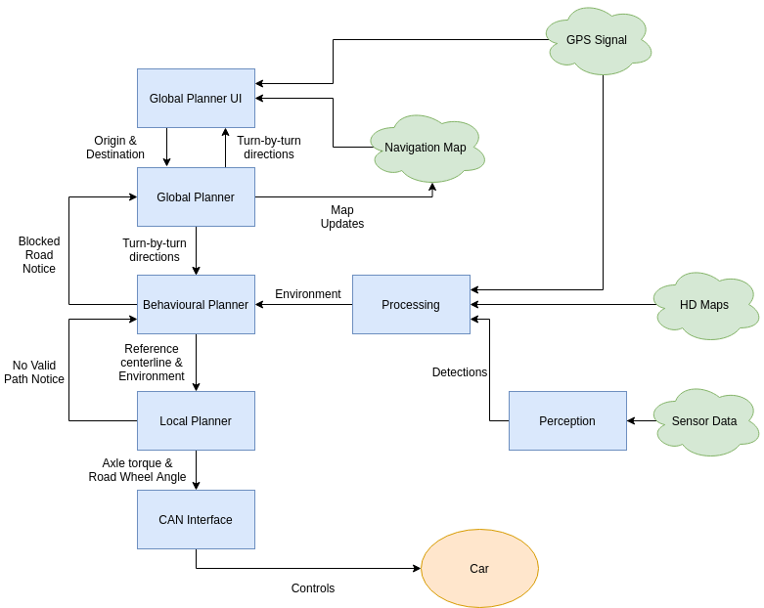

High level walkthrough of the mapping software architecture:

1. The Global Planner UI displays the most up to date map and route, and allows the pipeline operator to select new destination(s) and trigger a route request
2. The Global Planner receives the origin and destination from the Global Planner UI. Origin will be a link_id along with the current direction along the link. Destination will be the link_id the destination lies on, and the coordinates of the destination.
3. The Behavioral planner receives turn by turn directions (really they’re link-by-link directions) from the Global Planner, and the best understanding of the current Environment from Processing. Based on its internal state machine, the behavioural planner then decides on the high level behaviour the car should take (i.e. lane change, stop, turn right, …) and provides a desired trajectory polyline to the local planner along with the Environment (stopping lines are added into the environment if necessary). It is the Behavioral planner that checks whether there are obstacles blocking a road, in which case the blockage info is sent back to the global planner and a new route will be produced.
   1. Processing comes up with the best understanding of the current environment based on HD maps and detections from Perception. Only the locally relevant Environment elements will be passed to the Behavioral Planner (i.e. not all of the HD map).
   2. Processing makes the decisions about which elements from Perception and the HD maps should be trusted and used in Path Planning.
4. The local planner finds the most optimal feasible path it can, weighing the desire to follow the desired trajectory and the presence of obstacles. We use model predictive control for performing this optimization, and the result is desired axle torque and road wheel angle.
5. The CAN interface transforms the desired action into instructions that can actually be sent to the CAN bus.

**Physical System Architecture Plan**

* We won’t use any external computer. We will use the same crystal rugged that runs the rest of our software. The Global Planner will run as a ROS node.

**Description of strategy for navigation routing and re-routing**

* Have a Global Planner that plans high level routes using the Navigation Maps (i.e. which sequence of roads to follow), and a separate Local Planner that plans the local trajectory that tries to follow a reference line while avoiding obstacles and obeying constraints using the HD Maps and Perception data.
* Global Planner Details
  + Do a graph search on the Navigation Map to come up with routes. We have an existing implementation that uses A*, but may even switch to using a BFS to get optimal shortest paths because the map is small enough.
  + The origin point information used is the link_id the car is on with the current direction the car is facing; the destination point information used is the link_id the destination is on and its lat-long position so we know where to stop.
  + The turn-by-turn directions supplied to the behavioral planner are really link-by-link directions along with a stop location.
* Behavioural Planner details
  + To perform turns, the behavioural planner will tell the local planner to follow the lane that can turn in the desired direction. If the car is not in such a lane, the behavioural planner will tell the local planner to perform lane changes until we get in a lane we can stay in.
* Local Planner Details
  + Does model predictive control using a cost function that involves distance to reference line, distance to obstacles, distance to stop lines, distance to lane boundaries, ...
* Rerouting will be done when either the behavioural planner or the local planner determines there is an obstruction.
  + The behavioural planner will do simple checks for whether there are obstacles obstructing lanes (i.e. look at points spaced .5m along the centerline of the lanes and check if there is an obstacle within 1m)
  + The local planner will check whether the best planned trajectory violates any constraints (e.g. gets too close to an obstacle). If a constraint is violated, the car will stop and the Global Planner will reroute.
* There will be no concurrent routing done because the map is small enough that there should be no need to do such optimizations. We can add concurrent routing options later if we find we need any speed improvement, but this is unlikely; our compute bottlenecks will likely be in perception or other parts of the software stack.

**2. Questions for David**

* Is the format of the HD map and the navigation map supposed to be basically the same as in Year 2? (i.e. same field names and structure)
* Is there any reason why we would want to do simultaneous rerouting?
* Is there any reason why we would want to use an external computer?
* Suggested method of using HERE, SD maps in simulation? Could HERE just also provide them in OpenDrive format? (we would like to use the Here maps data in our path planning logic, but OpenDrive format for actually visualizing simulations) MSC mentioned that they have converted some Here maps data to OpenDrive format before for use with their VTD simulation software, but said that they would need permission from Here to convert the maps to OpenDrive format.
* Regarding the street where it goes from 4 lanes to 1 big lane and then back to 4, can’t we just edit the HD map to be better and always have 4 lanes?